**Project Development Phase**

|  |  |
| --- | --- |
| **Date** | 02 November 2022 |
| **Team ID** | PNT2022TMID17964 |
| **Project Name** | Smart Fashion Recommender Application |

**SENDGRID INTEGRATION WITH PYTHON CODE:**

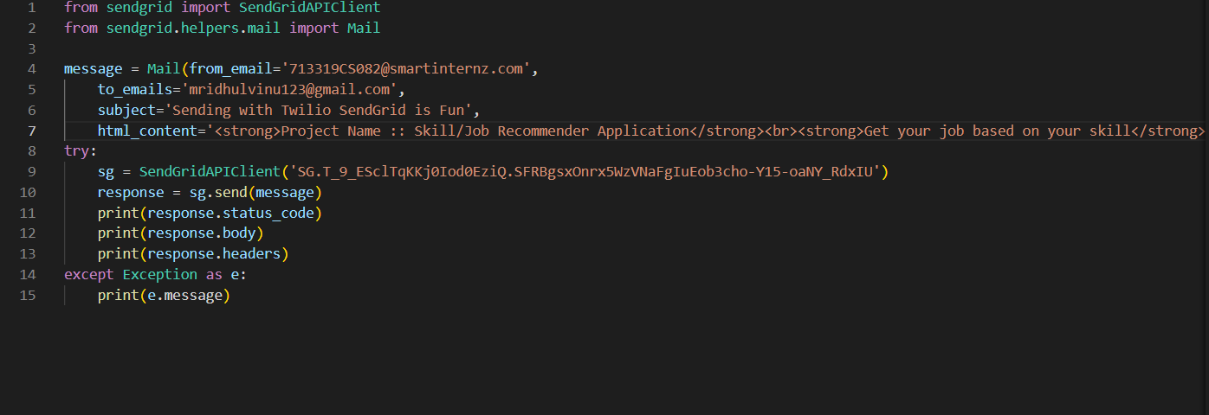

**EMAIL FROM SENDGRID:**

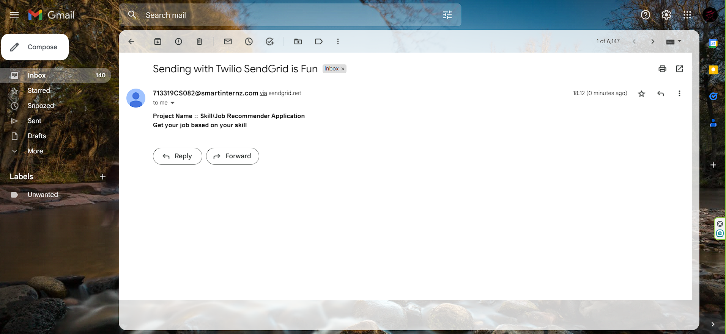

**BUILDING A CHATBOT:**

